GOVERNMENT OF THE REPUBLIC OF TRINIDAD AND TOBAGO
MINISTRY OF ENERGY AND ENERGY INDUSTRIES
Levels 15 & 22-26, Energy Tower, International Waterfront Centre #1 Wrightson Road Port of Spain
The Republic of Trinidad and Tobago West Indies
Tel : 868 225- 4EEI (4334), Fax: 868 – 225-5777 Email: info@energy.gov.tt
Media Release 19 April,2024

MINISTER YOUNG MEETS WITH BP’S EVP PRODUCTION & OPERATIONS TO DISCUSS NATURAL GAS PRODUCTION
On 19th April, 2024, the Honourable Stuart R. Young, M.P. Minister of Energy and Energy Industries and Minister in the Office of the Prime Minister, along with Mrs. Penelope Bradshaw-Niles, Permanent Secretary at the Ministry of Energy and Energy Industries, met with bp executives at the Ministry of Energy and Energy Industries’ International Waterfront Complex, Head Office, Port-of-Spain.
The bp executives present at the meeting were, Mr. Gordon Birrell, Executive Vice President (EVP) of Production & Operations bp; Mr. David Campbell, President bpTT; and Ms. Giselle Thompson, Vice President of Corporate Operations bpTT.
At the courtesy meeting with the energy minister, Mr. Gordon Birrell who is tasked with managing bp’s hydrocarbon production and exploration; and its gas production assets; detailed that he led a team from bp, comprised of geoscientists and other experts to look at the Columbus Basin and Trinidad and Tobago’s deep-water acreage, for opportunities to increase natural gas production in Trinidad and Tobago.
Mr. Gordon Birrell, also took the opportunity to congratulate the Honourable Stuart R. Young, M.P. Minister of Energy and Energy Industries and Minister in the Office of the Prime Minister, on the successful restructuring of Atlantic LNG, as the restructuring opened new opportunities for bpTT to invest in and collaborate with Trinidad and Tobago, in the pursuit of natural gas production.
As Mr. Gordon Birrell confirmed bp’s commitment to Trinidad and Tobago, the Honourable Stuart R. Young, M.P. Minister of Energy and Energy Industries and Minister in the Office of the Prime Minister, reiterated to the bp executives the importance of the partnership between bp and Trinidad and Tobago and his satisfaction with the continued open channels of communication between the company and the government. Minister Young then reaffirmed the government’s commitment to the relationship with bp as the company continues the management of projects that will bring gas discoveries and production to market, for the mutual benefit to both bp and the citizens of Trinidad and Tobago.
END
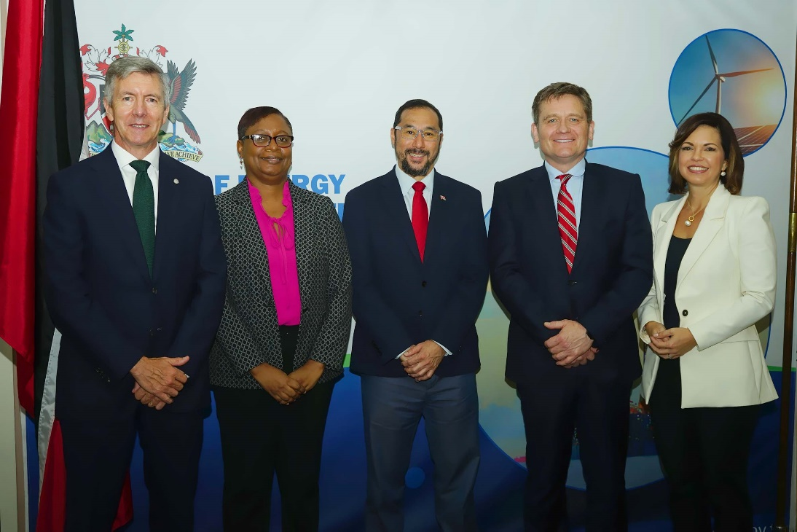
From left to right: Mr. David Campbell, President bpTT; Mrs. Penelope Bradshaw-Niles, Permanent Secretary at the Ministry of Energy and Energy Industries; The Honourable Stuart R. Young, M.P. Minister of Energy and Energy Industries and Minister in the Office of the Prime Minister; Mr. Gordon Birrell, Executive Vice President (EVP) of Production & Operations bp and Ms. Giselle Thompson, Vice President of Corporate Operations bpTT.

