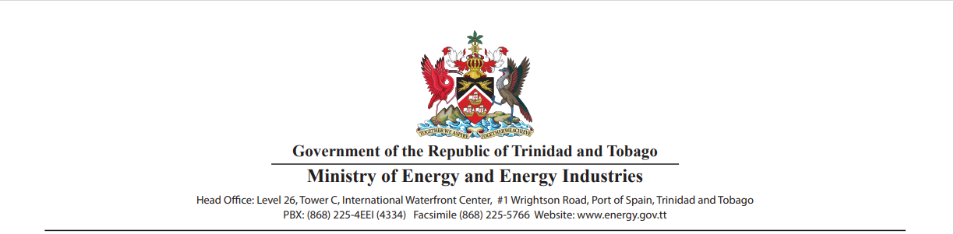

**DEEP-WATER COMPETITIVE BIDDING ROUND 2025**

**DATA PACKAGE REQUEST FORM**

**Name of Applicant:**

Provide your full name as it appears on official documents.

**Organization:**

Enter the name of the company, institution, or entity you represent.

**Job Title:**

Provide your official designation or role within the organization.

**Contact Information**

**Postal Address:**

Provide the full mailing address, including city, state, and country, where correspondence can be sent. Include the name of the person within your organization to whom the package should be addressed. Note: Use multiple lines within this field for input of address.

**Telephone No.:**

Enter a primary contact number, including the country code (e.g., +1-868-XXXXXXX).

**Secondary Contact No.:**

Enter a secondary contact number, including the country code (e.g., +1-868-XXXXXXX).

**E-mail Address:**

Enter an active email address for correspondence and updates regarding the data package.

**Company/Entity Information**

**Entity Type:**

Indicate the type of entity you represent [e.g., Government, National Oil Company (NOC), International Oil Company (IOC), Consortium, Other].

**Headquarters Location:**

Specify the city and country where the organization's headquarters are based.

**Date of Submission:**

Enter today’s date in the format DD/MM/YYYY.